*Bao Nguyen – S3877698*

**Lecturer:** Mr. Tom Huynh

**Submit Date:** 1 Jan 2024

**COSC2767 - System Deployment and Operations Assignment 2**

1 Jan 2024

Table of Contents

Introduction 1

Objective 1

Main Requirements 1

Setup EC2 1

Install JDK, Maven, Git, Tomcat and Jenkins 2

Configure Jenkins 2

Advanced Requirements 10

Conclusion 10

References 10

Appendix 10

EC2 Setup 10

Tomcat 10

Jenkins 14

Scripts 17

Tomcat 17

Jenkins 17

# Introduction

Pipeline, in software development context, refer to the automation sequence that commit will go through numeral steps to ensure the product quality, code convention, and product performance. The pipeline may include checkout, build, unit test, acceptance test, and deployment. This is known as CI/CD process which make it easy for an enterprise to ensure their product quality.

On this assignment, two main technologies will be used:

* Jenkins: an open-source tool for setting up pipeline for software development projects.
* Docker: a platform for developing and running applications in containers.

# Objective

In this assignment, we will establish a foundational pipeline that automatically rebuilds whenever a change is committed. This streamlined pipeline eliminates the need for manual intervention, ensuring a seamless and effortless workflow for developers.

# Main Requirements

## Setup EC2

On this section, we will create two EC2, one for Tomcat and one for Jenkins. Step by step instruction on how to launch instance is provided on appendix.

* Tomcat EC2 setup
* Jenkins EC2 setup

## Install JDK, Maven, Git, Tomcat and Jenkins

On this section, we will install necessary tools on each EC2 instances. Step by step instruction on how to install is provided on appendix.

* Install on Tomcat EC2
* Install on Jenkins EC2

## Configure Jenkins

**Step 1.** Connect to the Jenkins EC2, login as root user using sudo su -. And run service jenkins start.

**Step 2.** Navigate to port 8080 of the Jenkins public IP.

**Step 3.** Cat the Jenkins password and paste on the input.

**Step 4.** Navigate to manage jenkins tab

**Step 5.** On plugins tab, install GitHub, Deploy to container and Maven Integration plugins

**Step 6.** On tool tab, configure the path for the JDK. (the version on each install can be different, double check by ls /usr/lib/jvm to see the jdk version)

**Step 7.** Configure the path for maven as /opt/maven. Then click save

**Step 8.** Create new job.

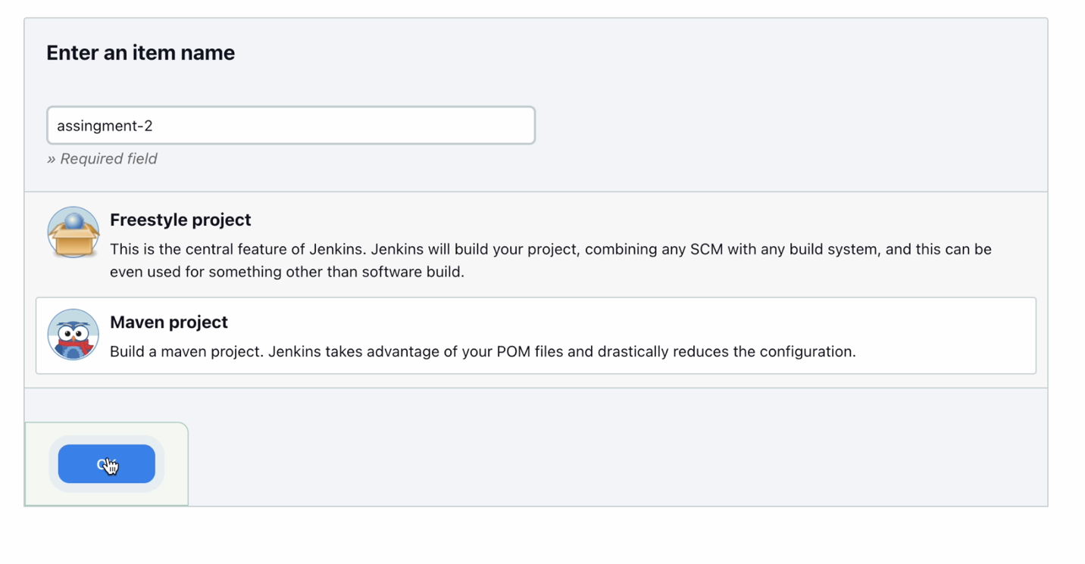**Step 9.** Choose maven project option and click OK

**Step 10.** Check the GitHub project and paste the link of the repository in

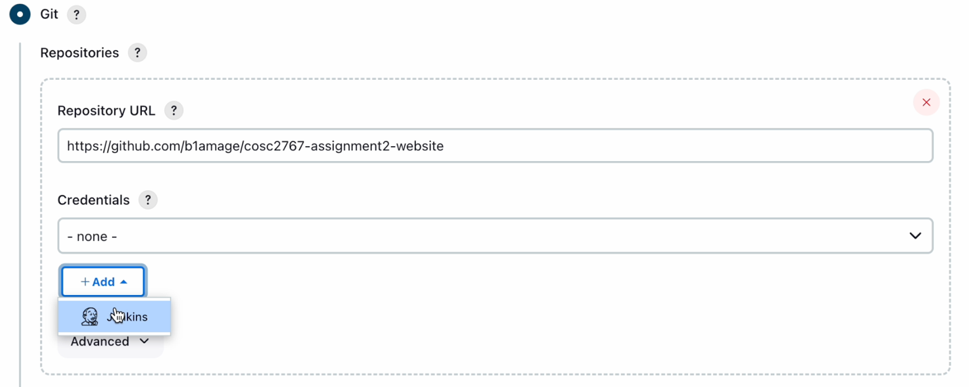

**Step 11.** Add Jenkins credentials.

**Step 12.** Setup username and password

**Step 13**. Change the branch from */master to */main

**Step 14.** Check the poll SCM and input `* * * * *`, this mean check every minute, if there is any change, rebuild the app.

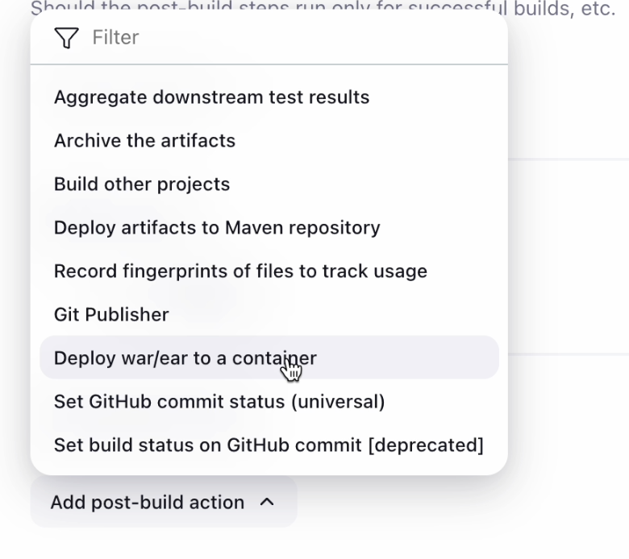

**Step 15.** On post-build action choose option deploy war/ear to a container

**Step 16.** Input **/*.war to war file and paste the tomcat link to Tomcat URL. This will link the application of tomcat to Jenkins. Then click save.

**Step 17.** Modify text and push.

**Step 18.** The pipeline is triggered.

**Step 19.** Website is re-built.

# Advanced Requirements

# Conclusion

This assignment has provided me with valuable insights, particularly in the setup and optimization of Jenkins for enterprise operations. The automated pipeline, when implemented comprehensively, emerges as a powerful solution, significantly economizing effort, resources, and costs for enterprises.

In technical terms, I have gained proficiency in enhancing project quality by configuring Jenkins for a GitHub repository. This newfound skill is poised to be a cornerstone in my approach to upcoming projects.

Moreover, my understanding of Docker has expanded, introducing me to its seamless application deployment capabilities. This knowledge promises to simplify the execution of running applications, adding another layer of efficiency to my skill set.

# References

# Appendix

## EC2 Setup

### Tomcat

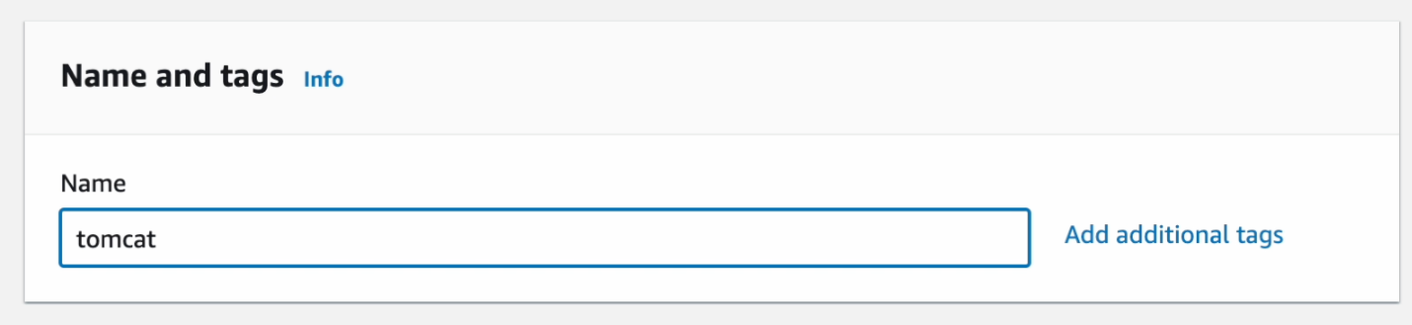

**Step 1**. Setup name

**Step 2.** Setup AMI

**Step 3.** Setup keypair

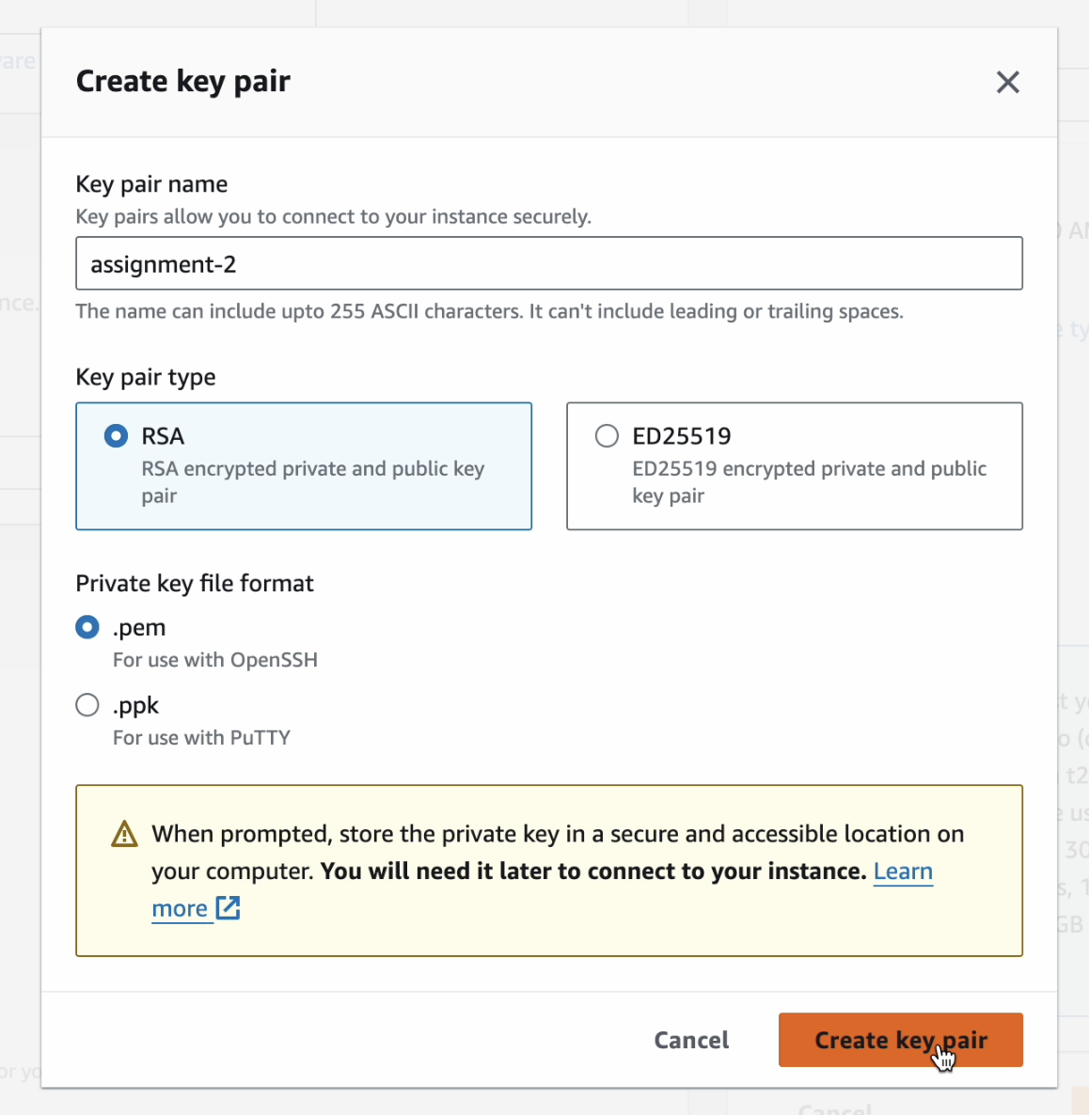

**Step 4**. Create key pair

**Step 5.** Setup security group

**Step 6.** Add custom port 8080

**Step 7.** Launch instance.

### Jenkins

**Step 1.** Setup name

**Step 2.** Setup AMI

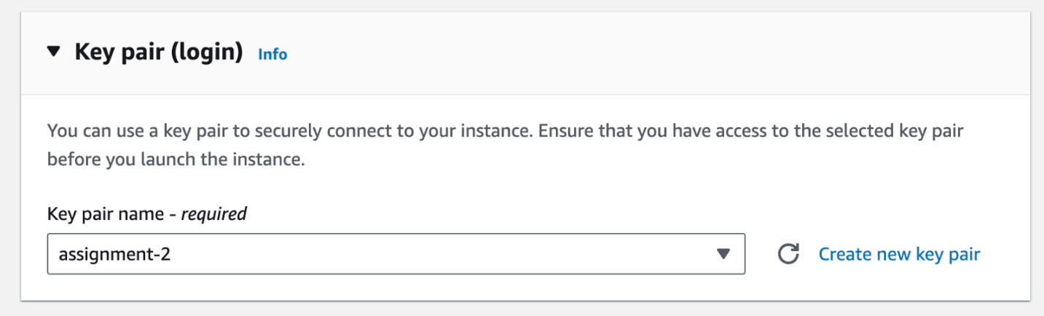

**Step 3.** Setup keypair

**Step 4.** Setup security group

**Step 5**. Add custom port 8080.

**Step 6.** Launch instance.

## Scripts

### Tomcat

**Step 1.** Install necessary package by running this bash script.

#!/bin/bash

sudo su -

# install jdk

sudo amazon-linux-extras install java-openjdk11 -y

# change directory to opt

cd /opt

# install tomcat

wget https://dlcdn.apache.org/tomcat/tomcat-9/v9.0.83/bin/apache-tomcat-9.0.83.tar.gz

# extract compressed tomcat file

tar -xvzf apache-tomcat-9.0.83.tar.gz

# rename it for rememberable name

mv apache-tomcat-9.0.83 tomcat

**Step 2.** On tomcat/conf/tomcat-users.xml, add this block of xml script.

<role rolename="admin-gui"/>

<role rolename="manager-gui"/>

<role rolename="manager-script"/>

<role rolename="manager-jmx"/>

<role rolename="manager-status"/>

<user username="admin" password="s3cret" roles="admin-gui,manager-gui, manager-script, manager-jmx, manager-status"/>

**Step 3.** On tomcat/webapps/manager/META-INF/context.xml, remove the <Value> tag.

**Step 4.** Start tomcat by running this bash script.

#!/bin/bash

# setup alias

ln -s /opt/tomcat/bin/startup.sh /usr/local/bin/tomcatup

tomcatup

### Jenkins

**Step 1.** Install necessary package by running this bash script.

#!/bin/bash

sudo su -

yum install git -y

# install jdk

sudo amazon-linux-extras install java-openjdk11 -y

# change directory to opt

cd /opt

# install maven

wget https://dlcdn.apache.org/maven/maven-3/3.9.5/binaries/apache-maven-3.9.5-bin.tar.gz

# extract compressed maven file

tar -xvzf apache-maven-3.9.5-bin.tar.gz

# rename it for rememberable name

mv apache-maven-3.9.5 maven

# install jenkins

sudo wget -O /etc/yum.repos.d/jenkins.repo https://pkg.jenkins.io/redhat-stable/jenkins.repo

sudo rpm --import https://pkg.jenkins.io/redhat-stable/jenkins.io-2023.key

yum install jenkins